ADA Checklist: Accessing Health Care Facilities

Site-Arrival, Parking, and Entrance
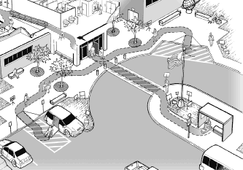

This checklist is designed to help you survey existing facilities and identify some of the common structural barriers that may impede or prevent individuals with disabilities from gaining access to your facility and receiving services, visiting patients, or participating in programs or services that you may offer to the general public.

You Will Need:
- Checklist
- Clipboard and pencils
- Tape measure, preferably at least 16 feet long
- Digital or carpenter’s level, preferably 24 inches long
- Door pressure gauge or fish scale for measuring door-opening force; if using a fish scale or double-action (push-pull) gauge, you may need a string or other way to attach the hook to a door handle
- Digital camera with plenty of memory capacity
- Spare batteries or charging capacity, as appropriate
- Bag to hold these items

Using Tools and Measuring

Measuring Tape
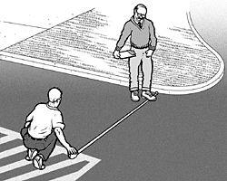
Keep your measuring tape straight and taut when measuring between two points.

When measuring the width of parking spaces and adjacent access aisles, measure from the centerline of the markings – from the center of one painted line to the center of the opposite painted line. If a parking space or access aisle does not adjoin another space or aisle (e.g. end of row) you can measure the full width of the painted line, or to the curb or edge of the level, usable space.

When measuring the clear width of a hinged doorway, open the door to 90 degrees. Place the end of the tape measure against the inner-most edge of the door frame, then stretch the tape across the open space to the face of the door itself.
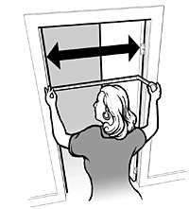

Slope
Slope is often expressed as a rise-to-run ratio, representing the relationship between height and distance. The vertical difference between two points – the height – is the “rise.” The horizontal difference – the distance – is the “run.”

Accessible routes can slope, but only within certain limits. An accessible route can have a slope of up to 1:20 for any distance. A slope of 1:20 means that for every 1 inch of rise, the route runs a distance of 20 inches.

If a route is steeper than 1:20, it is defined as a “ramp” and must have additional features, often including handrails. The slope of a ramp cannot be greater than 1:12; that is, for every 1 inch of rise, a ramp should run at least 12 inches. Any degree of slope between 1:20 and 1:12 is fine for a ramp, but anything steeper (for example, 1:6) becomes problematic.

Cross slope is the slope that runs perpendicular to, or across, the direction of travel. Cross slopes along accessible routes should not be greater than 1:48, which is just enough to allow water to run off.

Many surfaces that we think of as “level,” such as parking spaces, are also allowed to have these slight, 1:48 slopes to allow run-off.

If using a digital level, follow the instructions that come with the tool. Digital levels typically express slope as a percent, pitch, or in degrees. For example, a 1:20 slope is a 5% slope, and a 1:12 slope is an 8.33% slope. (See the chart on the following page for some common conversions.)
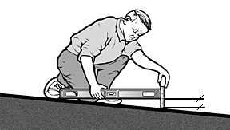
If using a carpenter’s level, place it on the sloped surface in the direction you want to measure. Lift the lower end until the bubble is centered between the marks in the tube, indicating the tool is level. Hold the tool steady and measure the distance between the ground surface and the bottom edge of the raised end of the level.

If the distance is two inches or less (using a level 24 inches long), then the slope is 1:12 or less (2:24 = 1:12). When measuring cross slopes, a distance of ½ inch or less indicates a slope of 1:48 or less.

When measuring the slope and cross slope of an accessible route or a ramp that is longer than a few feet, you should take measurements every few feet to check for consistency. The same is true when measuring the slope of surfaces that are supposed to be level (with slopes of 1:48 or less), such as accessible parking spaces or ramp landings. It is a good idea to take slope measurements in more than one place and in at least two perpendicular directions.

Slope Conversion Chart
Rise:Run | Percent | Pitch | Degree
1:8 | 12.50 | .1250 | 7.13
1:10 | 10.00 | .1000 | 5.71
1:12 | 8.33 | .0833 | 4.76
1:13 | 7.69 | .0769 | 4.40
1:14 | 7.14 | .0714 | 4.09
1:15 | 6.67 | .0667 | 3.81
1:16 | 6.25 | .0625 | 3.58
1:17 | 5.88 | .0588 | 3.37
1:18 | 5.55 | .0555 | 3.18
1:19 | 5.26 | .0526 | 3.01
1:20 | 5.00 | .0500 | 2.86
1:48 | 2.08 | .0208 | 1.19

Measuring Door Opening Force
The amount of force required to open a door, sometimes called “pressure,” can be measured using a gauge designed for this purpose, or even with a fish scale which can be purchased in many hardware or sporting goods stores.

Some door pressure gauges are “double-action” (often called “push-pull”); they have a hook on one end to measure force by pulling, and a rubber tip on the other end to measure force by pushing. Single-action gauges do not have a hook, and can only be used on the push side of a door.

Make sure your tool is set to zero, and the door is unlatched.

To measure force from the push-side of a door, place the rubber-tipped end of your gauge on the push plate or near the door hardware – where you would place your hand if you were going to push the door open with your hand. Push steadily on the door with the tool until the door is open to 90 degrees. A door pressure gauge will register the force used and maintain the reading until you reset it back to zero.

To measure force from the pull-side, attach the hook end of your gauge or fish scale to the door handle and pull the door open with the tool. Depending on the type of hardware the door has, you may need to use a loop of string to attach the hook to the door handle. Some fish scales are fairly sophisticated, including digital models, but some low-tech varieties will require you to keep your eye on the mechanism to note the maximum force registered as you open the door, as the scale will revert back to zero as soon as you release the door.

Measuring Force: Controls and Operating Mechanisms
You may need to measure the force required to activate controls, such as a push-button that opens a power-assisted door. In most cases, you can use the same tool and the same methods you use to measure door opening force.

Circulation Spaces: Vertical Clearance and Protruding Objects
Circulation spaces include both exterior and interior walkways, corridors, patios, parking lots, and any other rooms or spaces in the built environment where people move around. Circulation spaces do not include grassy areas people may “cut across,” or other undeveloped spaces not intended for circulation. However, circulation spaces are not limited to the “accessible routes” or other required clear spaces that are related to maneuvering for people who use wheelchairs or other mobility devices. All circulation areas need to have certain features that make it safe for people who are blind or have low vision to move around independently.
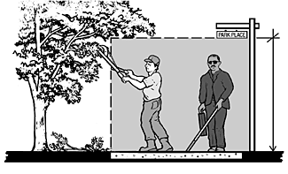

Circulation spaces need minimum vertical clearance (80 inches) for headroom; elements like low-hanging overhead signs or open staircases can pose dangers for people with vision disabilities, who may walk into them. Natural features, such as tree branches that overhang walkways or other circulation spaces, can also prove hazardous.

Circulation spaces also need to be free of hazardous protruding objects – things light fixtures mounted on walls or posts that project from the side between 27 and 80 inches above the ground. Wall-mounted objects should not protrude more than 4 inches, and post-mounted objects should not protrude more than 12 inches. Similar to low-hanging overhead items, objects intruding from the side may not be perceived by someone with a vision disability who navigates using a long cane to detect objects at ground level.
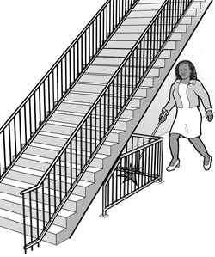

Low-hanging or protruding objects can sometimes be mitigated by the placement of barriers or detectable objects underneath or to the sides to prevent people from approaching too closely.

Get Ready
If site or building plans are available, you may find them helpful, but you should verify that they are still accurate. Sometimes things have changed over time and original drawings may not reflect current details.

Customize Your Checklist
This checklist is organized into four main sections, and the first section is further divided into three sub-sections:
- Site Arrival: Exterior Accessible Routes
  - Accessible Route
  - Curb Ramps
  - Ramps
- Parking
- Entrances
- Circulation Spaces: Vertical Clearance and Protruding Objects

Take a quick “tour” of the site to orient yourself and determine how many copies of the different checklist sections and sub-sections you will need. If there are separate parking lots or garages, different accessible routes between different site arrival points and accessible entrances, or multiple entrances you need to survey, you will want to use a separate checklist section for each of them.

If an accessible route does not include any curb ramps or ramps, you will not need those sub-sections. On the other hand, if one accessible route includes more than one curb ramp or ramp, you will need multiple copies of those sub-sections to survey each curb ramp and each ramp separately.

You will need to check for vertical clearance and protruding objects throughout all the areas you survey, so you may want to simply make several copies of the “Circulation Spaces” section of the checklist to have on hand as you proceed through your survey.

Locate site arrival points such as bus stops, public sidewalks, or drop-off areas; you will need to check the routes that connect these points to accessible entrances.

If your site is large, you may want to take your orientation tour by vehicle, and you may want to take this opportunity to count or verify the total number of parking spaces – that is the number of both accessible and inaccessible spaces – in your lot(s) or garage(s). If you have separate lots or garages, you will need to know the total number of spaces in each lot or garage.

If separate lots or garages serve different buildings, wings, or departments (out-patient clinics, diagnostic centers, rehabilitation facilities, etc.) or are restricted for the use of certain groups (employees only, visitors only, etc.) make note of this information. You’ll need it later.

Getting Started
One person can conduct a survey, but you may find it easier to work with a team of at least two people; having one person take measurements and the other record information works well.

Start from site arrival points (drop-off areas, bus stops, or public sidewalks), and check the accessibility of the routes from these points to the nearest accessible entrance. Check parking facilities (lots and garages), and the route from the accessible parking to the accessible entrance. Next check the entrances. If not all entrances are accessible, look for appropriate signage, including signs at inaccessible entrances directing people to the accessible entrance(s).

Look for maintenance issues; make note of problems like potholes or cracks in accessible surfaces, or bushes or tree limbs encroaching on spaces that should be kept clear.

Document, Document, Document
Take lots of notes and lots of photos! Taking multiple photos of the same space or element, from different distances or angles, is often helpful. It’s better to have more information than not enough. Even if you find things in compliance, it’s good to have detailed notes and accurate measurements. Always identify the spaces and locations associated with your checklist sections, sketches, notes, and photos (e.g. “west entrance” or “visitor parking lot”).

If you encounter items on the checklist that do not exist on your site, it is a good idea to make a note or write “N/A” to indicate the item does not apply to your site. This way, anyone who reviews the checklist will know the item was not overlooked.

Follow-Up
After completing the survey, you will need to compile your results and make plans to prioritize and address any barriers you identified. Contact your regional ADA Center for answers to your questions, individualized consultation, information about training programs, and helpful materials. You can find your regional Center through the ADA National Network (www.adata.org) or call the nationwide toll-free telephone line: 1-800-949-4232 V/TTY.

This checklist is based on the 2010 ADA Standards for Accessible Design (http://www.ada.gov/2010ADAstandards_index.htm) and was adapted from the ADA Checklist for Readily Achievable Barrier Removal (http://adachecklist.org/) produced by the New England ADA Center, a project of the Institute for Human Centered Design and a member of the ADA National Network (http://adata.org/).


Mid-Atlantic ADA Center
401 North Washington Street, Suite 450
Rockville, MD 20850
Toll Free: 800-949-4232 V/TTY
(DC, DE, MD, PA, VA, WV)
Local: 301-217-0124 V/TTY
Fax: 301-251-3762
www.adainfo.org

This document was developed under a grant from the Department of Education, NIDRR grant # H133A110017. However the contents do not necessarily represent the policy of the Department of Education, and you should not assume endorsement by the Federal Government.

Site Arrival: Exterior Accessible Routes

Date:

Building:

Location (identify route; e.g. “Oak St. bus stop to main entrance”):

Surveyor(s) and contact information:

This section of the checklist has three sub-sections: one for the general features of an accessible route (sidewalks or other pedestrian routes), one for curb ramps (often called “curb cuts”), and one for ramps. Accessible routes cannot include stairs, steps, or curbs; to be accessible, a route must have a way to go through, over, or around such obstacles.

If your site has more than one arrival point (e.g. a public bus stop and a parking lot), and the routes from these points do not coincide, and/or the site has multiple buildings, make a separate copy of this checklist section for each separate route you need to survey.

If two separate routes join at some point (e.g. the route from the bus stop and the route from the accessible parking join together at some point and then proceed as one to the entrance), include the joint route on one checklist, and simply make a note of reference on the other checklist.

You may also need copies of the “Circulation Spaces: Vertical Clearance and Protruding Objects” section to note any problems in these areas.

Curb Ramps and Ramps
Most curb ramps are “incised,” or “cut” inward, away from a street or parking lot. Some curb ramps are “built-up” to a curb, meaning they extend outward from the curb. Built-up curb ramps should never extend into vehicular pathways, or into the minimum dimensions required in accessible parking spaces and access aisles, as the full width and length of these spaces must be kept level and clear.

Many curb ramps have flared sides. Some have “returned curbs,” or vertical edges, which are fine as long as they are configured so that people don’t walk across them and trip. Curb ramps with returned curbs can have barriers such as grass, plants, or structural elements such as railings to prevent pedestrians from walking across them.

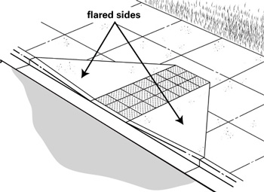
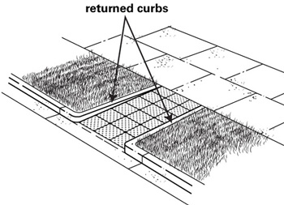

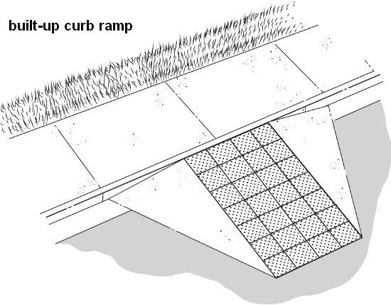

All ramps and ramp landings that have vertical drop-offs need some form of edge protection to keep people (or their wheels, cane tips, etc.) from slipping over the edge. Ramps with a rise of greater than 6 inches also need handrails.

ACCESSIBLE ROUTE
Item # | Item | Diagrams & Info | Response / Measurement | Comments / Photo #s
1.1 | Is the route stable, firm, and slip resistant? |  | □Yes □No | Photo #:
1.2 | Is the route at least 36” wide? | A route can narrow to 32” min. for a distance of 24” max. as long as such narrow sections are at least 48” apart.  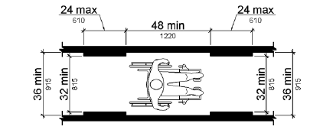 | □Yes □No  Measurement: | Photo #:
1.3 | If the route is less than 60” wide and runs longer than 200 feet, is there a passing space at least every 200 feet? | A passing space can be a square space at least 60” x 60” or a T-shaped intersection of two walking surfaces, each at least 36” wide, where the base and arms of the T extend at least 48” beyond the intersection. | □Yes □No  Measurement: | Photo #:
1.4a | If there are grates or openings along the route, are the openings no more than ½” wide? | 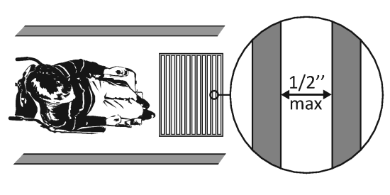 | □Yes □No  Measurement: | Photo #:
1.4b | If openings are elongated, are the long dimensions perpendicular to the direction of travel? |  | □Yes □No | Photo #:
1.5 | Is the running slope 1:20 or less?  If it is steeper than 1:20, go to item 1.14 to survey it as a ramp. | 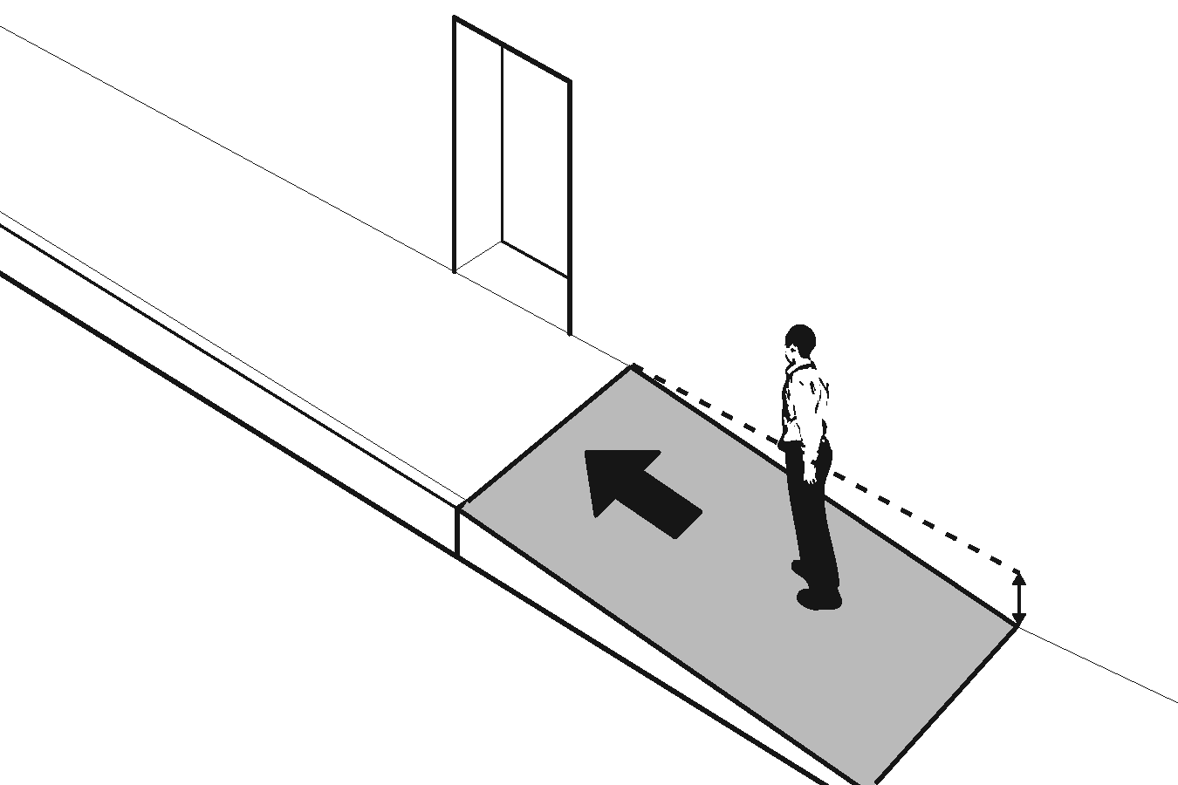 | □Yes □No  Measurement: | Photo #:
1.6 | Is the cross slope 1:48 or less? | 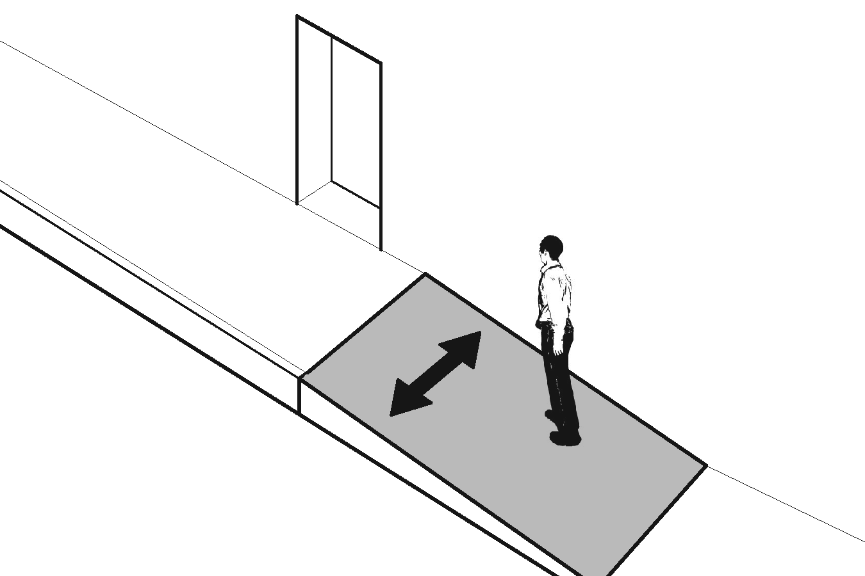 | □Yes □No  Measurement: | Photo #:
1.7a | Do circulation areas have at least 80” of vertical clearance? | Use the “Circulation Spaces” checklist section if you need to identify multiple problems with vertical clearance or protruding objects. | □Yes □No  Measurement: | Photo #:
1.7b | Are circulation areas free of hazardous protruding objects? |  | □Yes □No  Measurement: | Photo #:

CURB RAMP
Item # | Item | Diagrams & Info | Response / Measurement | Comments / Photo #s
1.8 | Is the curb ramp, not including any flared sides, at least 36” wide? | 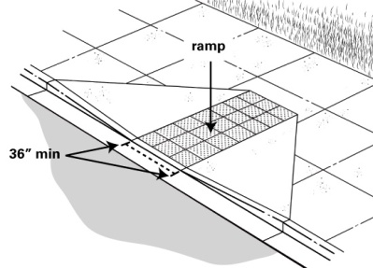 | □Yes □No  Measurement: | Photo #:
1.9 | Is the running slope of the curb ramp no steeper than 1:12? | 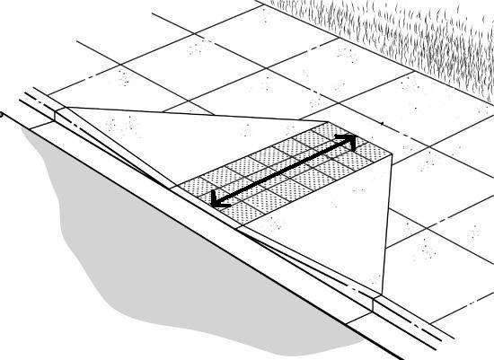 | □Yes □No  Measurement: | Photo #:
1.10 | Is the cross slope of the curb ramp no steeper than 1:48? | 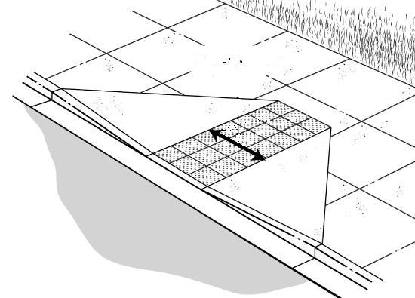 | □Yes □No  Measurement: | Photo #:
1.11 | At the top of the curb ramp, is there a level landing (slope no steeper than 1:48 in all directions) that is at least 36” long and at least as wide as the curb ramp? | 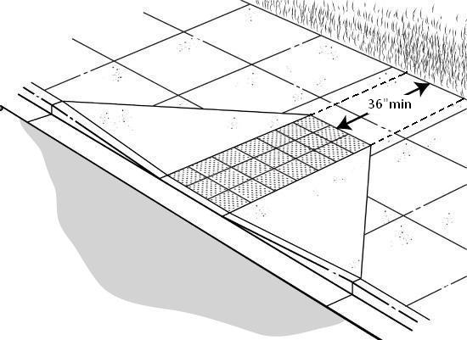 | □Yes □No  Measurement: | Photo #:
1.12a | If YES (landing is at least 36” long), and there are flared sides, are the slopes of the flared sides no steeper than 1:10? | 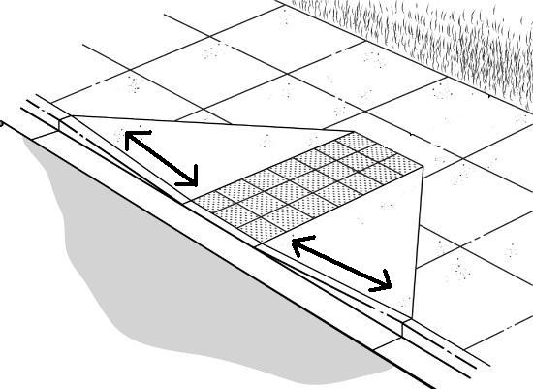 | □Yes □No  Measurement: | Photo #:
1.12b | If NO (landing is not at least 36” long), are there flared sides with slopes no steeper than 1:12? |  | □Yes □No  Measurement: | Photo #:
1.13 | Are transitions flush at top and bottom of the curb ramp? | Tranistions should be smooth, without “lips,” “dips,” other abrupt changes in level, or steep gutters.  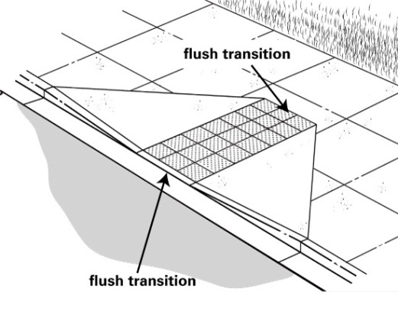 | □Yes □No | Photo #:

RAMP
Item # | Item | Diagrams & Info | Response / Measurement | Comments / Photo #s
1.14 | Is the ramp at least 36” wide? | If there are handrails, measure between the handrails.  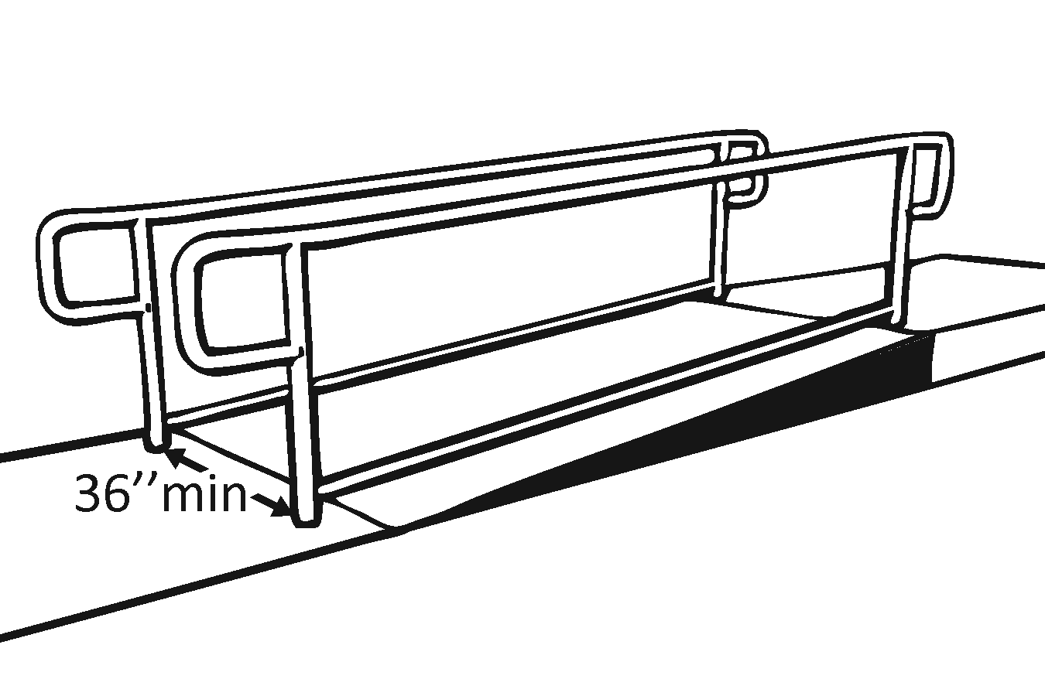 | □Yes □No  Measurement: | Photo #:
1.15 | Is the surface stable, firm and slip resistant? |  | □Yes □No | Photo #:
1.16 | Is the running slope of each section of the ramp no steeper than 1:12? | At existing facilities, rises no greater than 3” with slopes no steeper than 1:8, and rises no greater than 6” with slopes no steeper than 1:10 are permitted when such slopes are necessary due to space limitations. | □Yes □No  Measurement: | Photo #:
1.17 | Is the cross slope of each section of the ramp no steeper than 1:48? |  | □Yes □No  Measurement: | Photo #:
1.18 | Is the rise of the ramp, or any segment of the ramp, no more than 30”? |  | □Yes □No  Measurement: | Photo #:
1.19a | At the top of the ramp, is there a level landing that is at least 60” long and at least as wide as the ramp? | 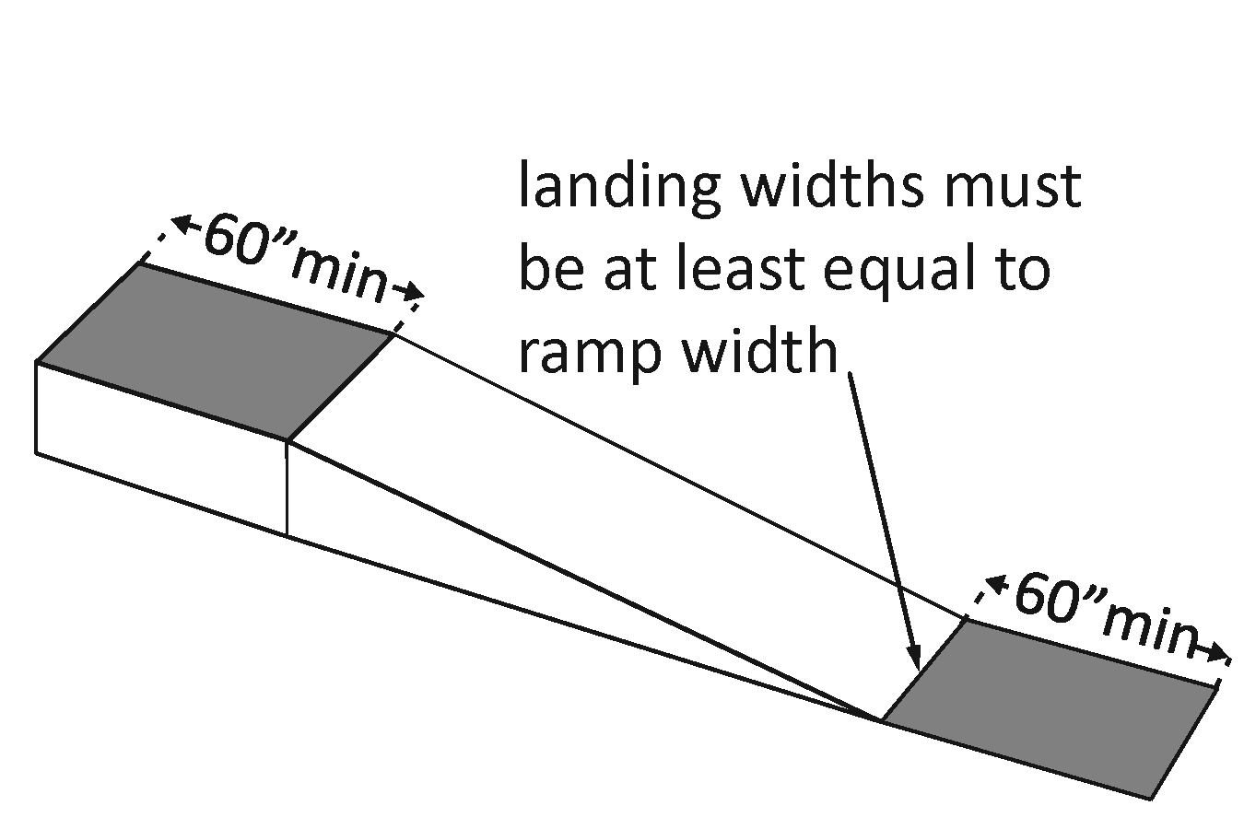 | □Yes □No  Measurement: | Photo #:
1.19b | At the bottom of the ramp, is there a level landing that is at least 60” long and at least as wide as the ramp? |  | □Yes □No  Measurement: | Photo #:
1.20 | If the ramp changes direction, is there a level landing that is at least 60” x 60”? | 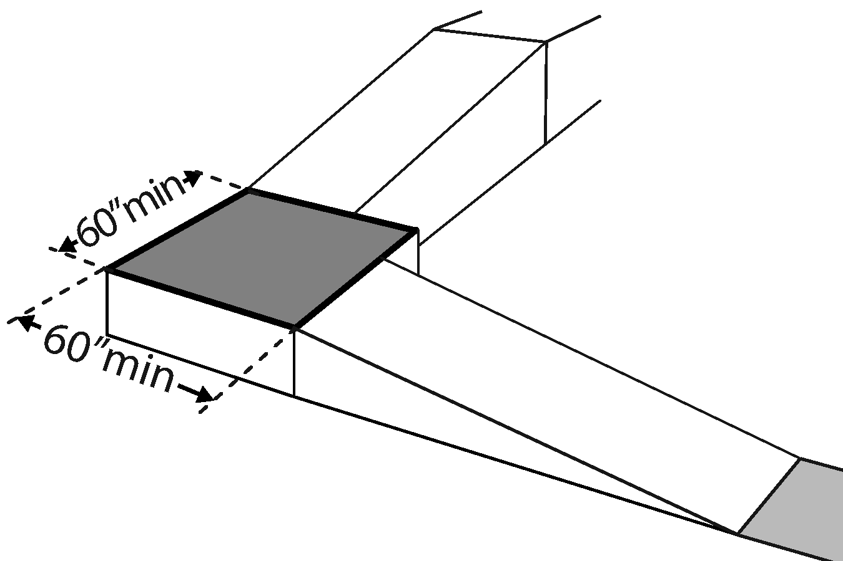 | □Yes □No  Measurement: | Photo #:
1.21 | If the ramp has a rise greater than 6”, are there handrails on both sides? | 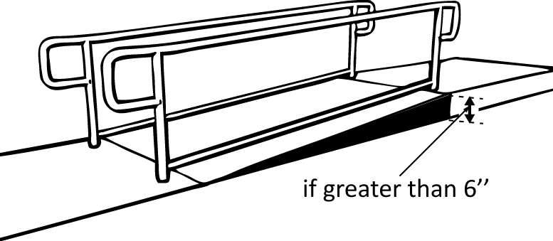 | □Yes □No | Photo #:
1.22 | Is the top of the handrail gripping surface between 34” and 38” above the ramp surface? | 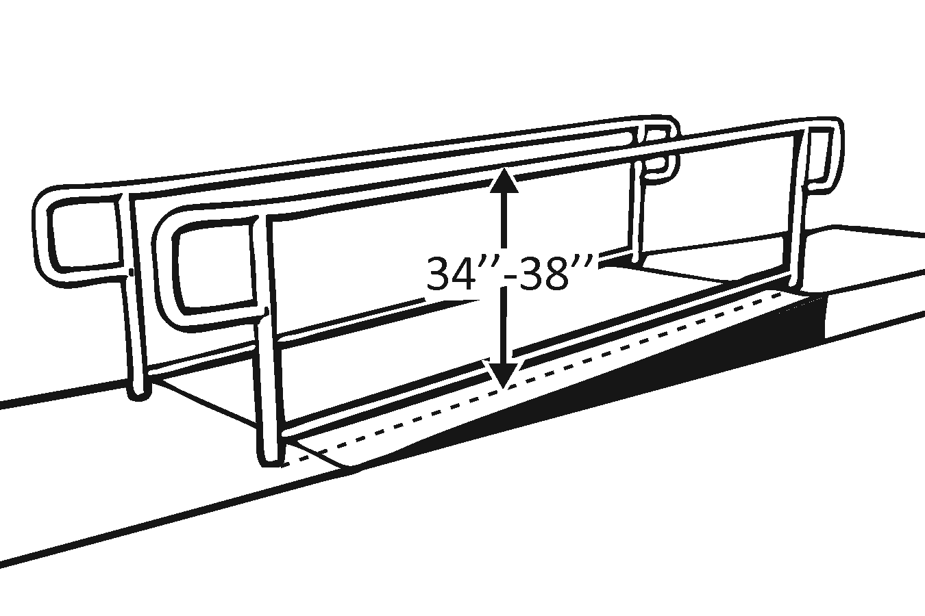 | □Yes □No  Measurement: | Photo #:
1.23a | Is the handrail gripping surface continuous and not obstructed along the top or sides? | 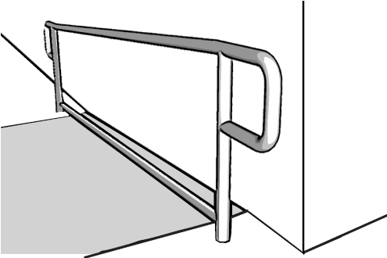 | □Yes □No | Photo #:
1.23b | Is the bottom of the handrail gripping surface obstructed (by supports, etc.) for no more than 20% of its length? |  | □Yes □No  Measurement: | Photo #:
1.24a | If the handrail is round, is it between 1¼” and 2” in diameter? | 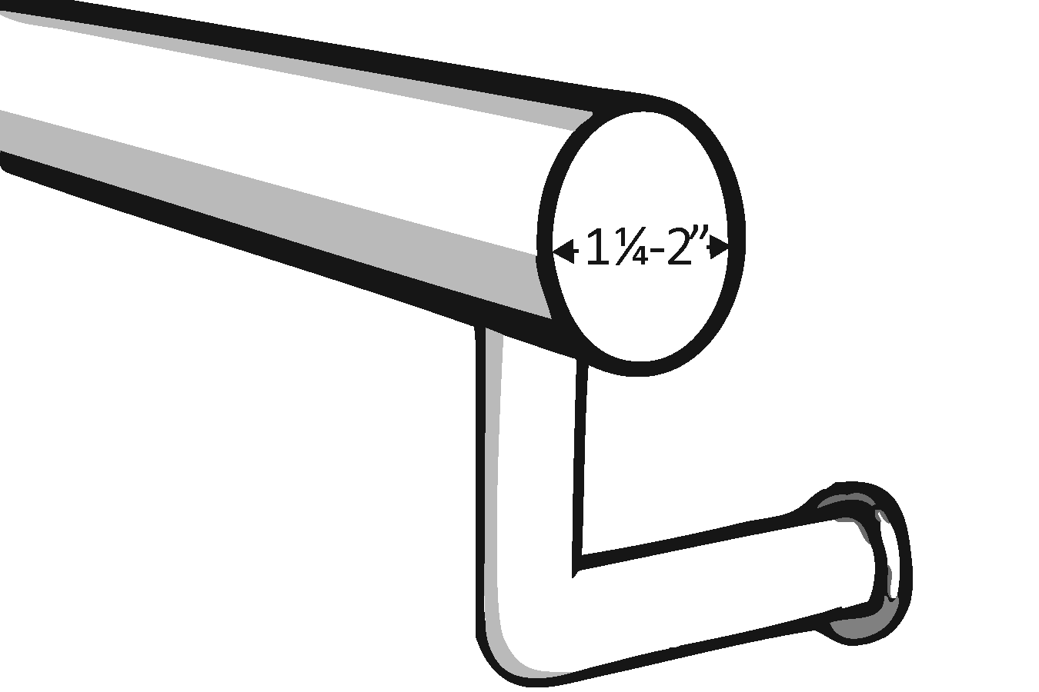 | □Yes □No  Measurement: | Photo #:
1.24b | If the handrail is not round, is it between 4” and 6” in perimeter and no more than 2¼” in cross section? | 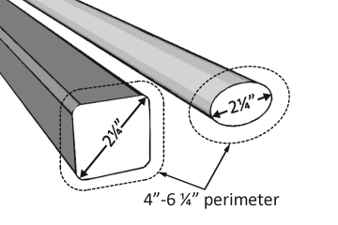 | □Yes □No  Measurement: | Photo #:
1.25a | Does the handrail extend at least 12” horizontally beyond the top and bottom of the ramp? | 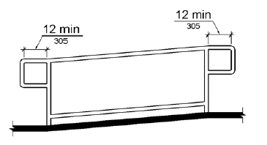 | □Yes □No | Photo #:
1.25b | Does the handrail return to a wall, guard, or landing surface? |  | □Yes □No | Photo #:
1.26 | To prevent wheelchair casters and crutch tips from slipping off the edge, does the surface of the ramp extend at least 12” beyond the inside face of the handrail?  OR  Is there a curb or barrier that prevents the passage of a 4” diameter sphere? | 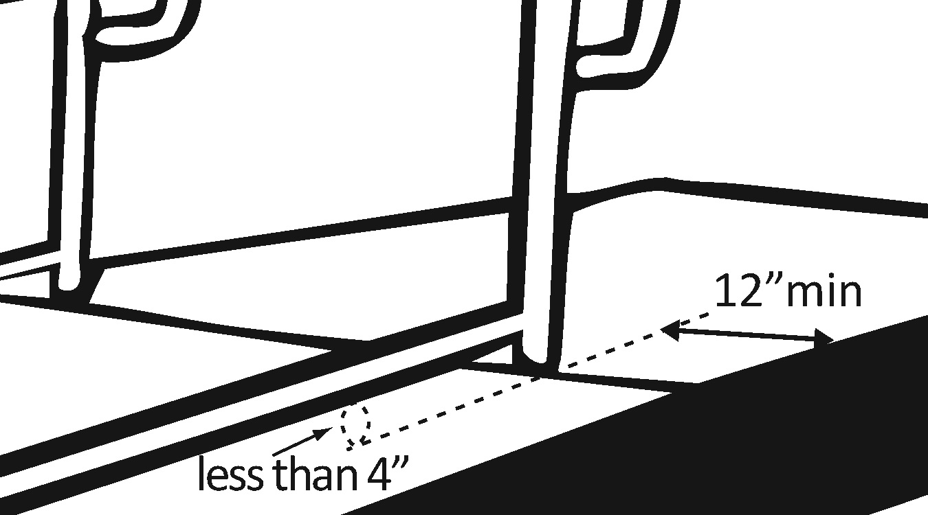 | □Yes □No  Measurement:  □Yes □No  Measurement: | Photo #:

Site Arrival: Parking

Date:

Building/entrance served by the parking:

Lot or garage:

Surveyor(s) and contact information:

Use the information below and the chart that follows to determine how many accessible parking spaces need to be provided in each parking facility (lot or garage).

Many health care facilities, including doctors’ offices, mental health counseling centers, and inpatient hospitals, must provide a “basic” level of access if they provide parking facilities. Some types of medical facilities need to provide a greater level of access in parking facilities that serve patients and visitors. These types of facilities include:
- Hospital outpatient facilities (10% of total patient/visitor parking spaces need to be accessible)
  - Facilities or units located in hospitals and that provide regular and continuing medical treatment without an overnight stay; doctors’ offices, independent clinics, or other facilities not located in hospitals are not considered hospital outpatient facilities
- Rehabilitation facilities specializing in treating conditions that affect mobility, and outpatient physical therapy facilities (20% of total patient/visitor parking spaces need to be accessible)
  - Conditions that affect mobility include conditions requiring the use of a brace, cane, crutch, prosthetic device, wheelchair, or powered mobility aid; arthritic, neurological, or orthopedic conditions that severely limit one’s ability to walk; respiratory diseases and other conditions which may require the use of portable oxygen; and cardiac conditions that impose significant functional limitations

Employee-only parking: Note that parking facilities that are for employee use at any type of health care facility are subject to the requirements for the basic level of access, but only when they are newly constructed or altered (resurfaced, restriped, expanded, etc.). Employees may need to be accommodated on an individual basis, but customers are the focus of general barrier removal activities in existing facilities. Parking facilities that are restricted for the use of employees can be “factored out” of the barrier removal equation. You do not need to survey or address access problems in employee-only parking areas (although you may want to).

If a single parking facility serves more than one type of building or more than one type of population (employees, patients and visitors), you may need to determine how many of the spaces are intended for the different purposes. Sometimes the original building code requirements for the provision of total parking spaces can help you sort out how many spaces are intended to serve the different facilities or building occupant loads. You may be able to obtain this information from the original building plans or from your local building department.

Dispersed accessible parking: Where a single parking facility serves multiple buildings or accessible entrances, accessible parking spaces should be dispersed to enable people to park near as many accessible entrances as possible.

For example: A hospital has two accessible public entrances; the main entrance on the north side of the facility and the emergency department entrance on the east. The hospital is served by one large parking lot which wraps around the north and east sides of the building. The parking lot has a total of 500 spaces, so 9 accessible parking spaces are needed; they should be divided so that some are available near the main entrance and some are available near the emergency department entrance.

“Grouped” accessible parking: On the other hand, where separate parking facilities serve the same building or entrance, accessible spaces may be grouped together, as long as the number of spaces provided is first determined according to each of the separate parking facilities.

For example: A hospital has an adjacent parking lot with 200 spaces and a separate parking garage a block away, with an additional 500 spaces. The adjacent lot needs 6 accessible spaces, and the remote garage needs 9 accessible spaces. Since accessible spaces need to be as near as possible to the facilities they serve, the 15 accessible spaces can be grouped together in the lot adjacent to the hospital, and the remote garage can have none.

Scoping: Accessible Parking
Total number of spaces in lot/garage | Total number accessible spaces (basic) | Total number accessible spaces (hospital out-pt., pt./visitor) | Total number accessible spaces (rehab./mobility, out-pt. PT, pt./visitor)
1 - 25 | 1* | 10 percent* | 20 percent*
26 - 50 | 2* | 10 percent* | 20 percent*
51 - 75 | 3* | 10 percent* | 20 percent*
76 - 100 | 4* | 10 percent* | 20 percent*
101 - 150 | 5* | 10 percent* | 20 percent*
151 - 200 | 6* | 10 percent* | 20 percent*
201 - 300 | 7* | 10 percent* | 20 percent*
301 - 400 | 8* | 10 percent* | 20 percent*
401 - 500 | 9* | 10 percent* | 20 percent*
501 - 1000 | 2 percent* | 10 percent* | 20 percent*
1001 and over | 20, plus 1 for each 100, or fraction thereof, over 1000* | 10 percent* | 20 percent*
1 out of every 6 accessible spaces (but always at least 1) in all types of lots/garages
must be van-accessible (wider)

State Requirements
Many states have additional, very specific requirements related to accessible parking spaces. For example, many states require the use of specific colors for pavement striping or signage, posting of penalties or fines for illegal parking in accessible spaces, or even a greater number of accessible spaces. It is important to check your own state or local standards and make sure you comply with them in addition to ADA requirements.

PARKING
Item # | Item | Diagrams & Info | Response / Measurement | Comments / Photo #s
1.27 | Are the appropriate numbers of accessible parking spaces provided? | Refer to the “scoping” chart on the previous page. | □Yes □No  Total #:  Accessible #: | Photo #:
1.28 | Of the accessible parking spaces, are the appropriate numbers van-accessible? | At least 1 of every 6, or faction of 6, accessible spaces should be van-accessible. | □Yes □No  Van-accessible #: | Photo #:
1.29 | Is each standard accessible space at least 8 feet wide, with an access aisle at least 5 feet wide? | Two spaces may share an access aisle between them.  If spaces are not all the same and some or all do not meet minimum standards, identify the spaces and record the variations (use the back of the page if necessary).  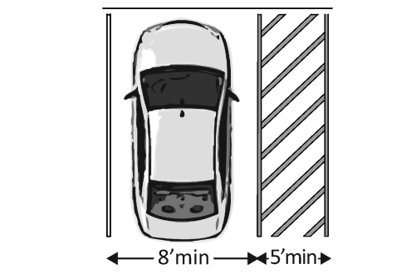 | □Yes □No  Measurement: | Photo #:
1.30 | Is each van-accessible space at least 11 feet wide with an access aisle at least 5 feet wide?  OR  at least 8 feet wide with an access aisle at least 8 feet wide? | 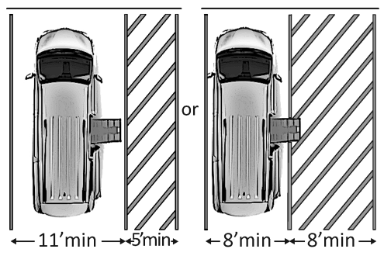 | □Yes □No  Measurement: | Photo #:
1.31 | Are there at least 98” of vertical clearance available for each van-accessible space and access aisle? | Make sure to also check the vertical clearance of the vehicular route that leads to the space.  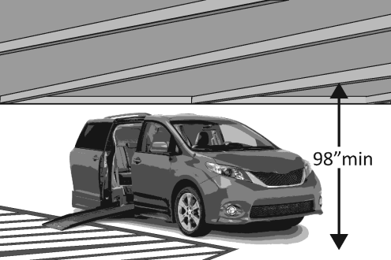 | □Yes □No  Measurement: | Photo #:
1.32 | Are all access aisles marked to discourage parking in them? | 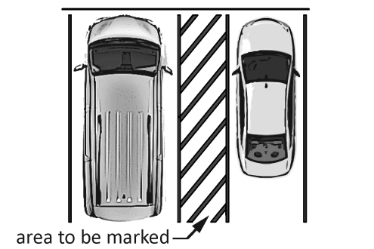 | □Yes □No | Photo #:
1.33 | Is the slope of all accessible parking spaces and access aisles (full width and length) no steeper than 1:48 in all directions? |  | □Yes □No  Measurement: | Photo #:
1.34 | Do all access aisles adjoin an accessible route? | 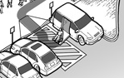 | □Yes □No | Photo #:
1.35 | Are accessible spaces identified with signs that include the International Symbol of Accessibility (ISA)? | 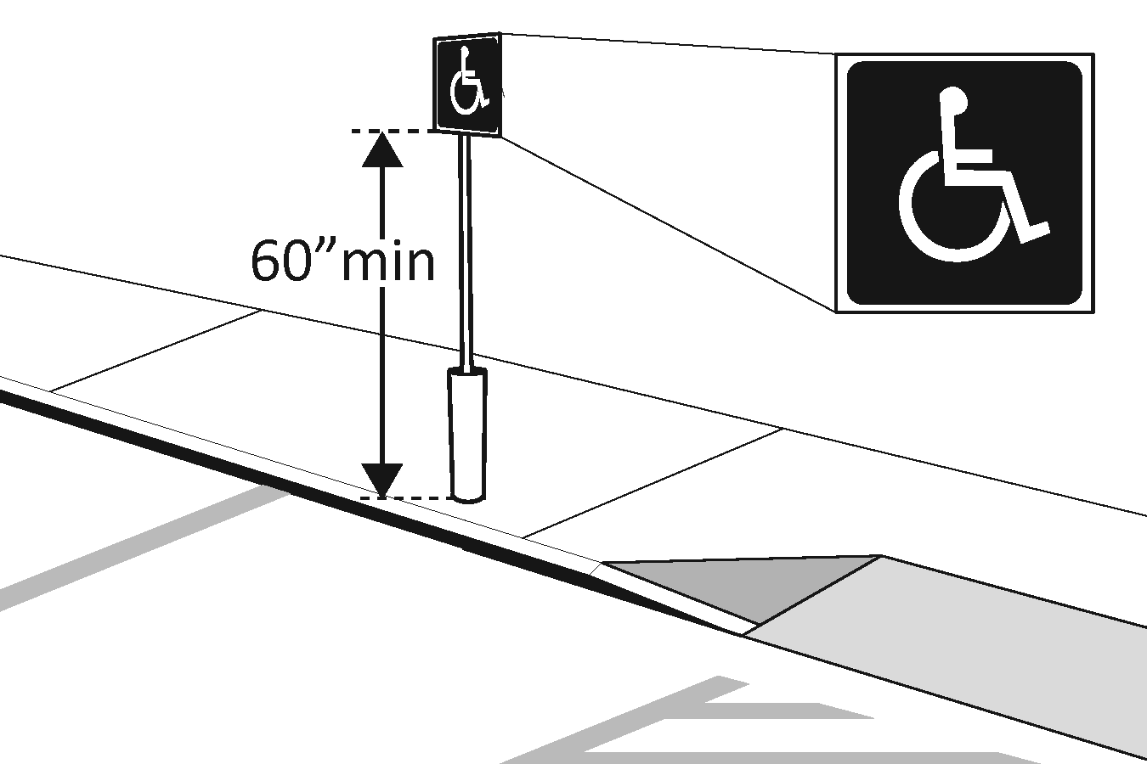 | □Yes □No | Photo #:
1.36 | Are the signs installed so that the bottom edges are at least 60” above the ground? |  | □Yes □No  Measurement: | Photo #:
1.37 | Are there signs reading “van-accessible” at van-accessible spaces? | 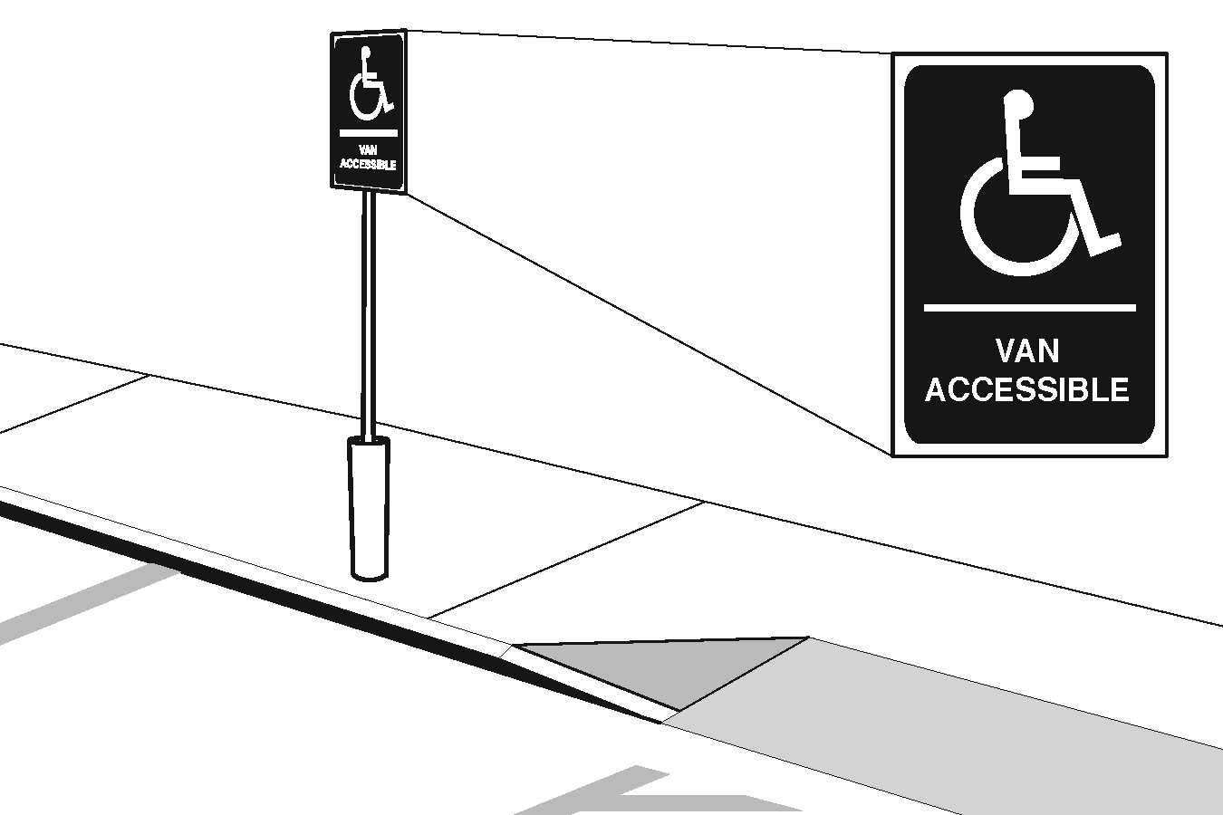 | □Yes □No | Photo #:
1.38 | Are the accessible spaces located on the shortest accessible route to the entrance they serve? |  | □Yes □No | Photo #:
Use the “Accessible Route” checklist section, as well as the “Curb Ramp” and “Ramp” sections if needed, to survey the route from the accessible parking to the entrance(s) served.

Site Arrival: Entrances

Date:

Building:

Entrance (identify each entrance you survey; e.g. “main entrance,” “south entrance”):

Surveyor(s) and contact information:

In newly constructed buildings, at least 60 percent of public entrances must be accessible, as well as any entrances that are directly connected to parking structures, elevated walkways, or tunnels. Accessible routes for people with disabilities are supposed to coincide as much as possible with the routes used by the general public, so to foster integration and ease of use, the “main” entrance to any building should always be accessible if possible.

Doors
An accessible door has certain features, such as minimum clear width and clear, level space sufficient to allow a person using a mobility device to approach the door, operate it, and move through it.

There are several types of doors that can be accessible, including sliding, folding, and “hinged” (swinging) doors. Any type of revolving door cannot be part of an accessible route.

Accessible doors may be manually operated, or they may be automatic or power-assisted.

Automatic and power-assisted doors are not required by the ADA Standards, but they may provide a solution where existing conditions (e.g. lack of maneuvering space) make it difficult to provide access with a manually operated door.

An automatic door is activated by a motion, light, or pressure sensor. A person doesn’t have to do anything purposeful to open an automatic door.

Power-assisted doors are usually activated by pushing a button. Push buttons must be located so that individuals with disabilities can approach, reach, and operate them without being within the swing of a door, and the buttons should be easy to push, requiring no more than 5 pounds of force.

Closers
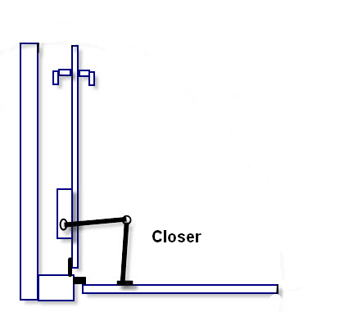
Many manual swinging doors have “closers” installed at the top. Closers create tension that causes doors to close on their own after being opened. A closer that creates excessive tension can affect closing speed or the force needed to open a door.

Opening Force
The maximum force required to open a manually operated accessible exterior door is not specified in the ADA Standards, although fire doors must have the minimum opening force allowed by the appropriate administrative authority (building department, fire department, etc.). A minimum of 15 pounds of force is not an uncommon standard for fire doors. Your local authority may be able to help you determine which doors in your facility are fire doors and what opening force requirements apply to them.

Some state or local codes do establish requirements related to force for accessible exterior doors (that are not fire doors); a typical requirement is a maximum of 8 ½ pounds of force. Regardless of whether your state has a standard, it is a good idea to measure the force required to open manually operated exterior doors that need to be accessible at your facility. If such doors require a force of greater than 15 pounds to operate, they can certainly present difficulties, and possibly even safety risks, for individuals with disabilities or others with limited strength.

Maneuvering Clearances
Use the diagrams on the following pages to determine how much maneuvering space is needed at a manually operated swinging door, and how the space should be configured, based on these factors:
- Direction of approach (a person approaches from the front, from the latch side, or from the hinge side of a door)
- Approach from the pull side or the push side (exterior doors typically swing outward, so approaching an exterior door from the outside of the building will usually put you on the pull side)
- Alcoves and recesses (doors with obstructions within 18 inches of the latch, that project more than 8 inches in a perpendicular direction from the plane of the face of the door)

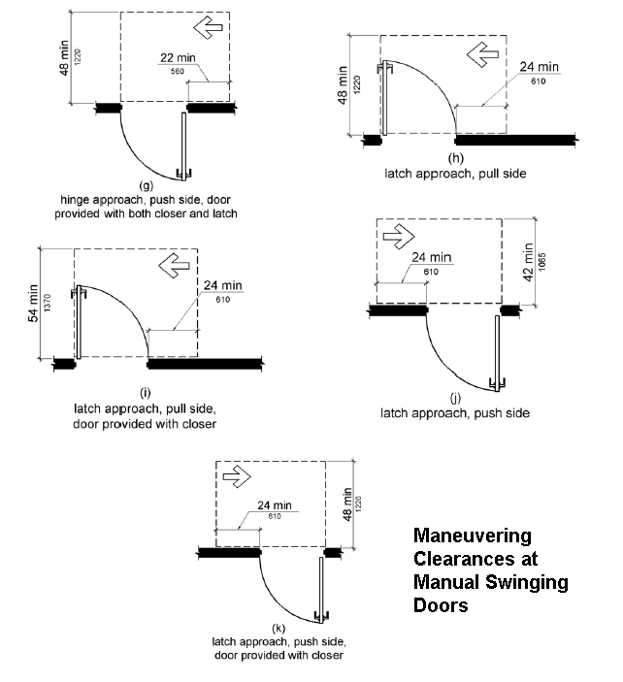

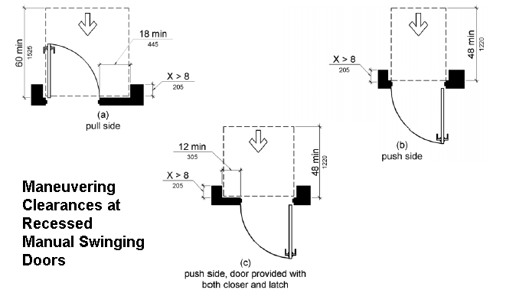

ENTRANCE
Item # | Item | Diagrams & Info | Response / Measurement | Comments / Photo #s
1.39 | Is the main entrance accessible? |  | □Yes □No | Photo #:
1.40 | If the main entrance is not accessible, is there an alternative entrance that is accessible? | 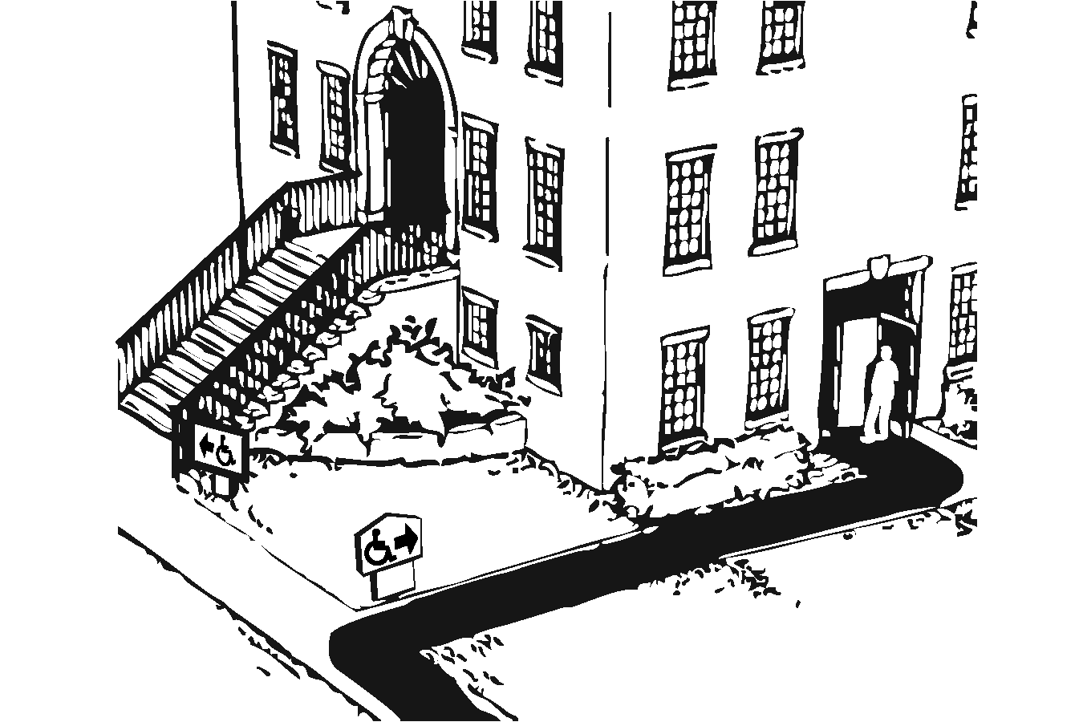 | □Yes □No | Photo #:
1.41 | If an alternative entrance is used for accessibility, is it open during the same hours as the main entrance? |  | □Yes □No | Photo #:
1.42 | Do inaccessible entrances have signs indicating the location of the nearest accessible entrance? | 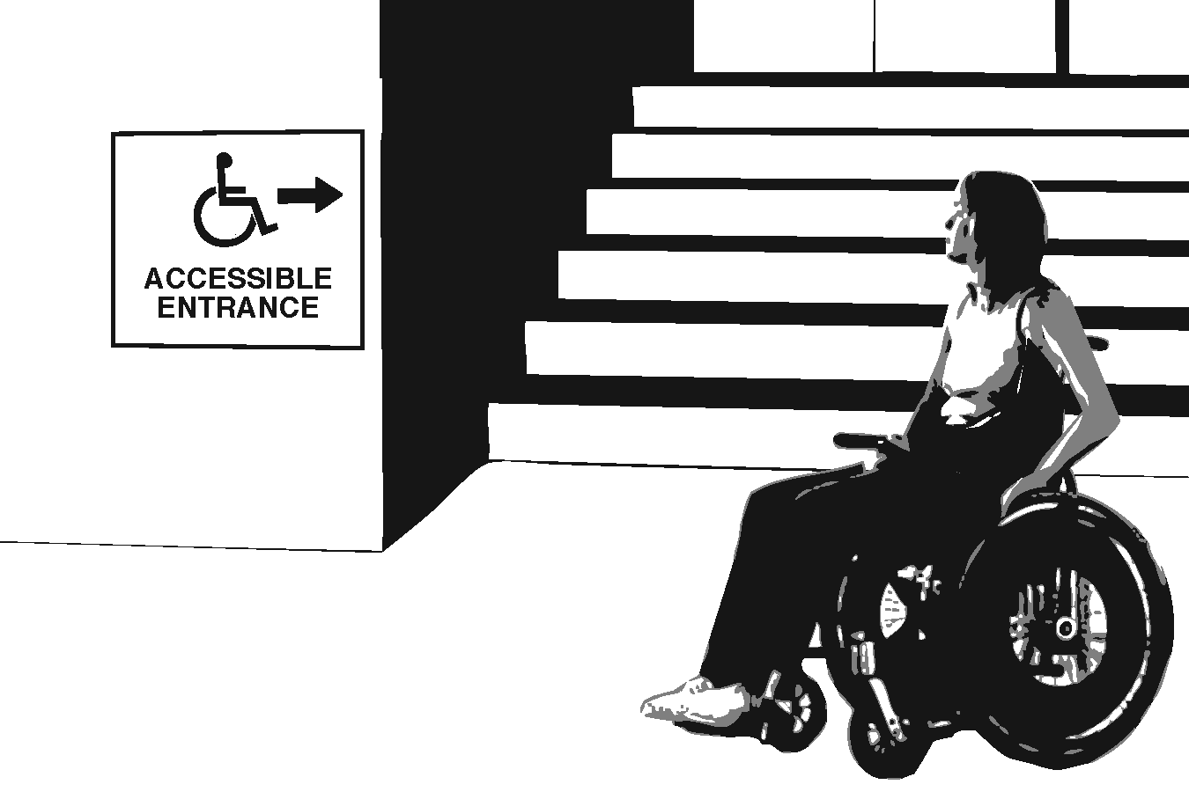 | □Yes □No | Photo #:
1.43 | Do accessible entrances have signs that include the International Symbol of Accessibility (ISA)? | 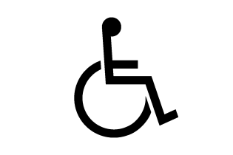 | □Yes □No | Photo #:
Use items 1.44 through152 below to survey manually operated doors, swinging doors (not automatic or power-assisted doors).
1.44 | Is there sufficient clear space for maneuvering at the door? | Refer to the diagrams on the preceeding pages to determine the appropriate clearance needed for a particular door. | □Yes □No  Measurement: | Photo #:
1.45 | Is the maneuvering space at the door level (slope no more than 1:48 in any direction)? |  | □Yes □No  Measurement: | Photo #:
1.46 | Does the door have a clear width of at least 32”? | 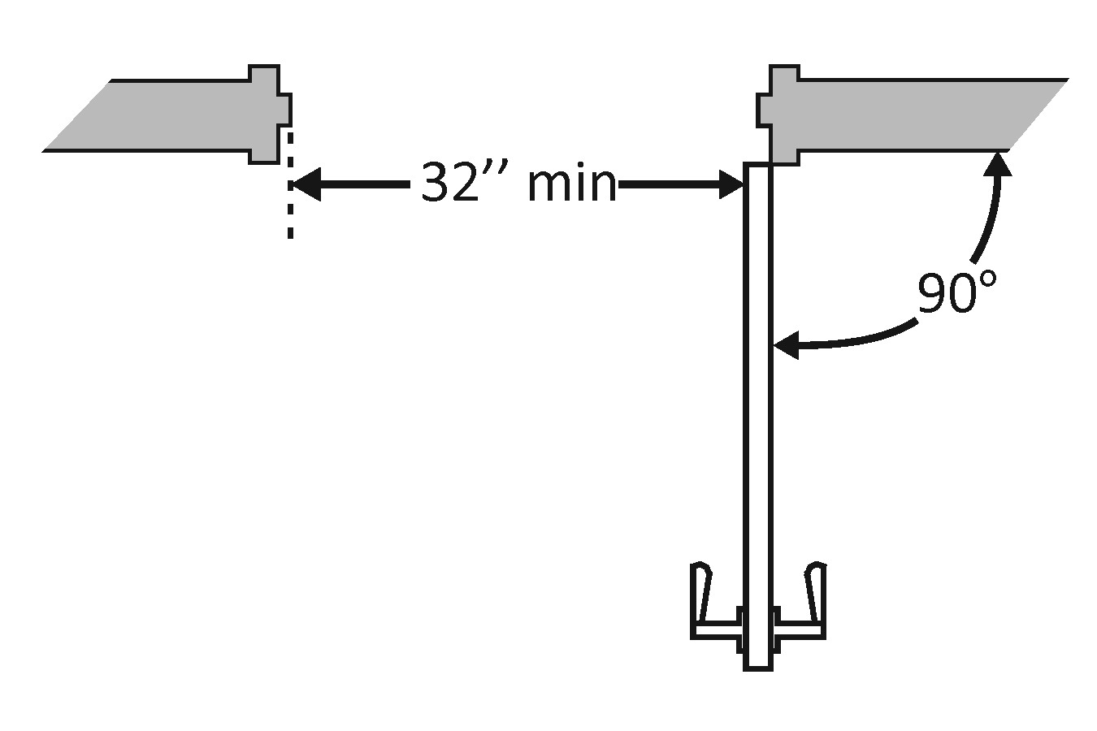 | □Yes □No  Measurement: | Photo #:
1.47 | Is the threshold no higher than ¼”?  OR  No higher than ¾” if beveled with a slope no steeper than 1:2? | The first ¼” of a threshold may be vertical; additional height must be beveled.  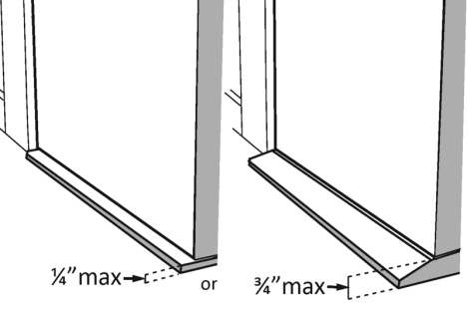 | □Yes □No  Measurement: | Photo #:
1.48a | Is the door hardware operable with one hand and does not require tight grasping, pinching, or twisting of the wrist? | Examples of accessible door hardware:  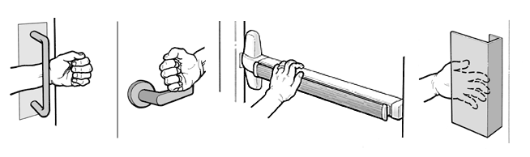 | □Yes □No | Photo #:
1.48b | What is the maximum force required to open the door? | See “Opening Force” in the introduction to this section. | Measurement: | Photo #:
1.49 | If the door has a closer, does it take at least 5 seconds to close from an open position of 90 degrees to a position of 12 degrees from the latch? | 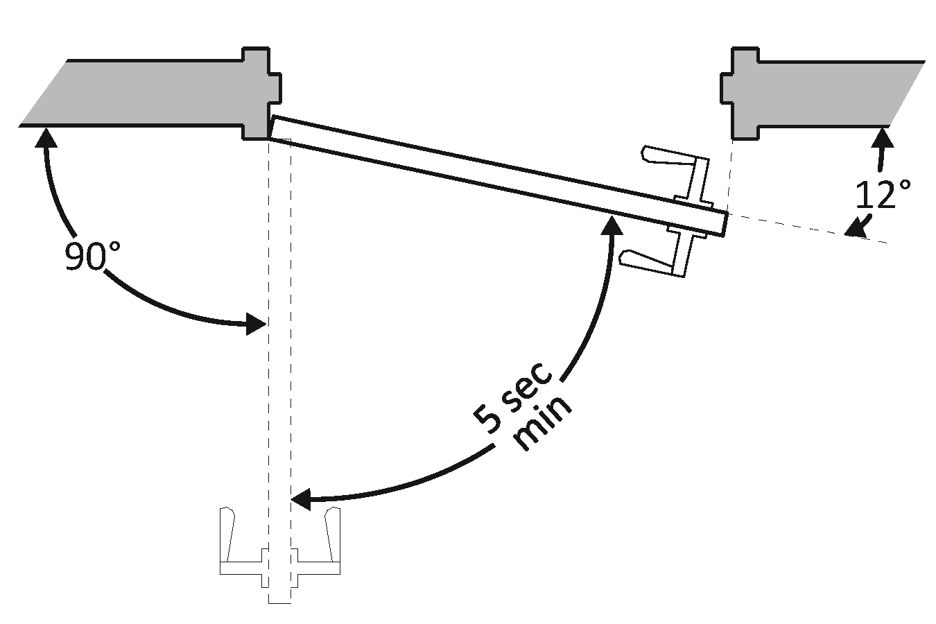 | □Yes □No  Measurement: | Photo #:
1.50 | If there are two doors in a series (creating a vestibule), are there at least 48” of clearance inside the vestibule, not including the width of any door that swings into the vestibule? | 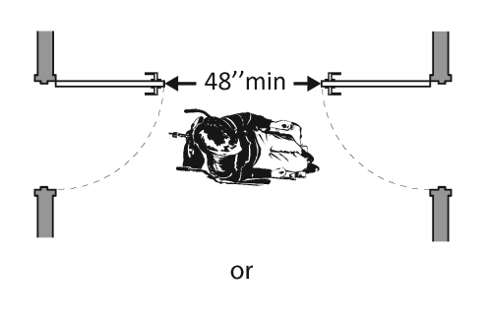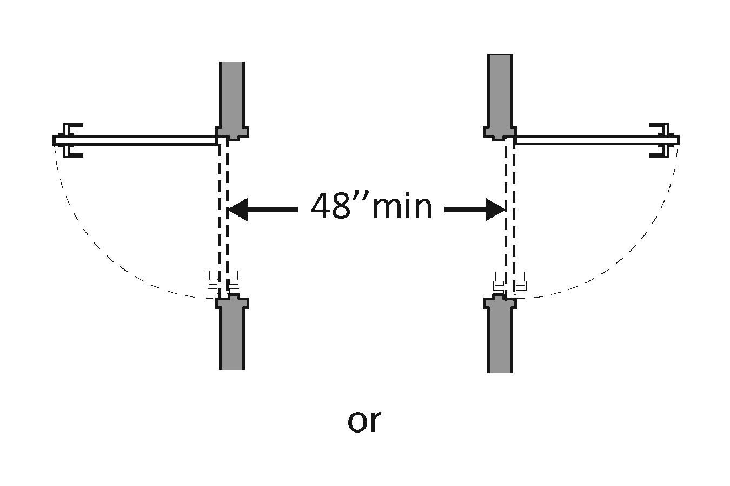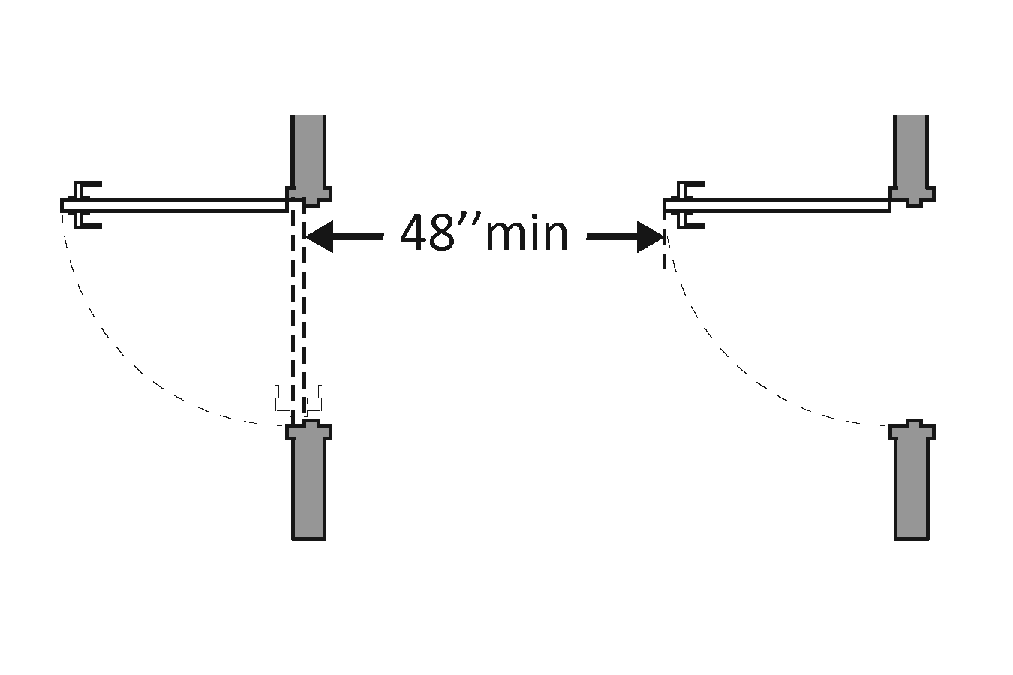 | □Yes □No  Measurement: | Photo #:
1.51 | If there are carpets or mats at the entrance, is the pile no higher than ½”? | 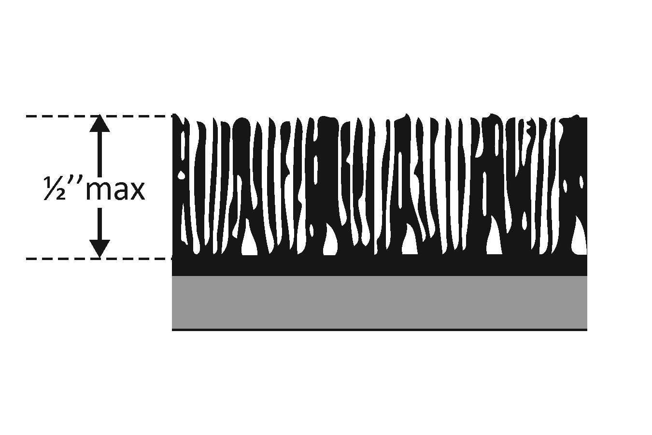 | □Yes □No  Measurement: | Photo #:
1.52 | Are the edges of carpet or mats securely attached to minimize any tripping hazard? |  | □Yes □No | Photo #:

Site Arrival: Circulation Spaces
Vertical Clearance and Protruding Objects

Date:

Building/area:

Surveyor(s) and contact information:

Circulation spaces need to have a minimum of 80 inches of vertical clearance (although door closers and door stops may be as low as 78 inches).
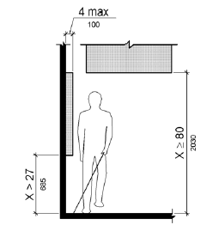

Objects that protrude from walls between 27 and 80 inches above the ground should not protrude more than 4 inches (although handrails can protrude up to 4 ½ inches).

Objects that protrude from posts or pylons between 27 and 80 inches can overhang up to 12 inches.
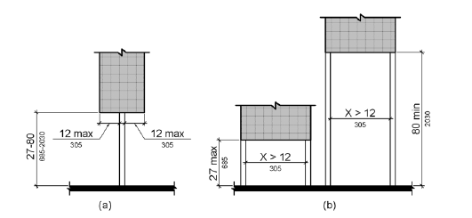

CIRCULATION SPACE
Item # | Item | Diagrams & Info | Response / Measurement | Comments / Photo #s
1.53 | Is at least 80” of vertical clearance maintained throughout the circulation area? | 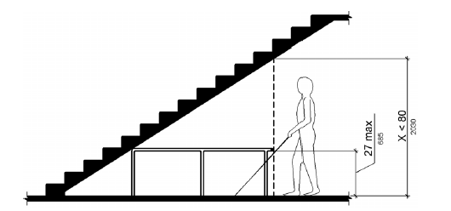 | □Yes □No  Measurement: | Photo #:
1.54 | Do wall-mounted objects located between 27” and 80” above the ground (e.g. awnings, fire-extinguishers) protrude no more than 4” into circulation spaces? | Object with leading edges lower than 27” or higher than 80” above the ground can protrude any amount.  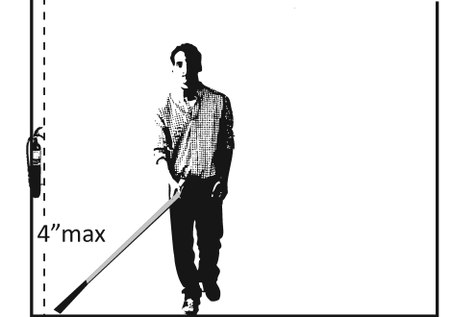 | □Yes □No  Measurement: | Photo #:
1.55 | Do post-mounted objects (e.g. signs) overhang circulation spaces by no more than 12”? |  | □Yes □No  Measurement: | Photo #:

